***Golf Club Database Project***

**Description:**

The Golf Club Database project is designed to manage the information of club members and provide functionalities to filter members based on certain criteria.

**Classes:**

**Member:** This class represents a golf club member. It contains private fields such as MemberID, LastName, FirstName, Handicap, Gender, Team, MemberType, Coach, Phone, and JoinDate. The class also provides getter methods for accessing these fields and a display() method to print member information.

**Date:** This class represents a date with fields for day, month, and year. It provides getter methods to access these fields.

**Filter:** This class contains methods to filter members based on different criteria. It includes methods like joinDate() to filter members based on join date, seniorHandicapScore() to filter senior members with handicap score less than 12, and seniorFemaleTeamB() to filter senior female members in Team B.

**GolfClubDB:** This is the main class of the project. It contains the main() method where the program execution starts. It initializes the members array, creates an instance of the Filter class, and calls the filtering methods to display the filtered members.

**Project Process and Output:**

**Initialization:** The initialiseMembers() method initializes the members array with information about club members, including their ID, name, handicap, gender, team, member type, coach, phone number, and join date for values that are not available are assigned as “-1” and displayed as null.

**Filtering Process:**

***Filter by Join Date:***

The joinDate() method of the Filter class filters members based on the provided join date. It compares the join date of each member with the provided date and displays the members who joined before the provided date.

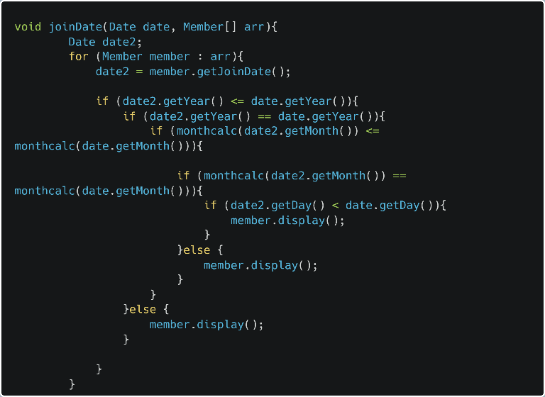

***Filter Senior Members with Handicap Score:***

The seniorHandicapScore() method filters senior members with a handicap score less than 12. It iterates through the members array and displays the senior members who meet the criteria.

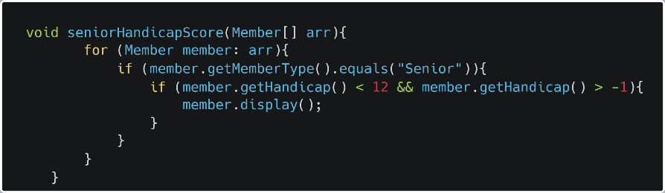

***Filter Senior Female Members in Team B:***

The seniorFemaleTeamB() method filters senior female members in Team B. It checks the gender, team, and member type of each member and displays the members who meet the specified criteria.

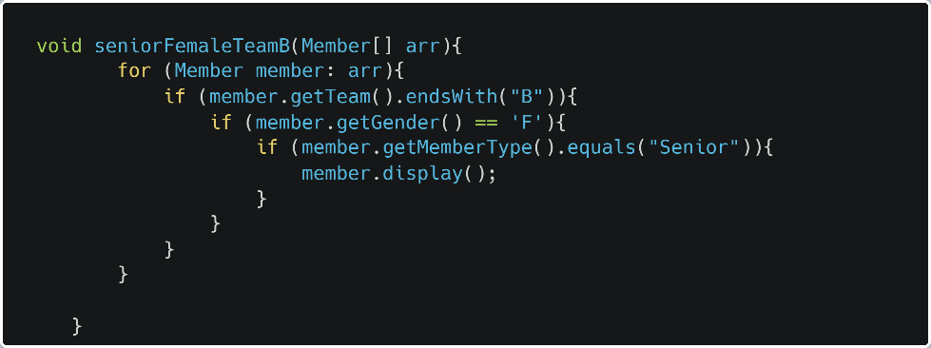

**SAMPLE OUTPUT:**

